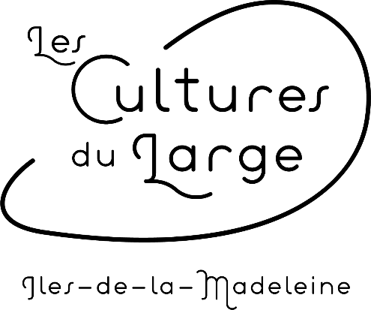
Mariculture Excursion
Information

Visit our aquaculture farm and familiarize yourself with mariculture on our new boat, the Memquit. In the lagoon or on the high seas, discover how our delicious mollusks are cultivated.

The excursion starts with a visit of our Interpretation center.
Oyster tasting aboard the boat included.
Duration of the visit: 30 minutes
Duration of the sea trip: 1:30

Prices: Adult: $80.00 + tx
Child (12 years old and under): $45.00 + tx
Baby (12 months and under): Free
* A discount is possible for agencies. Please call us for more information.

Excursion hours:
Monday to Friday, at 10:00 or at 13:30
• To authorize a departure, we need a minimum of 4 persons.
• The groups are of 12 persons maximum.
• You must pay when you make your reservation.
• In case of bad weather, the excursion will be moved to the following days. Because of that, it is highly suggested that you plan your excursion at the beginning of your stay on the archipelago.

*** In case it is impossible for you to do the excursion at another date, we will give you your money back. ***
• Any cancellation made less than 48 hours before will not be refunded.

The day of the excursion:

• You must be at the Interpretation center located at 26, chemin du Quai, Havre-aux-Maisons, at the time of the chosen excursion to visit the center, join your guide and receive the instructions for safety at sea.
• Clothing adapted for the sea trip. A warm coat, comfortable shoes and sunglasses are suggested.

For more information or to make a reservation, call at (418) 969-4477, send an email at info@lesculturesdularge.com or come see us at 26, chemin du Quai, Havre-aux-Maisons.

